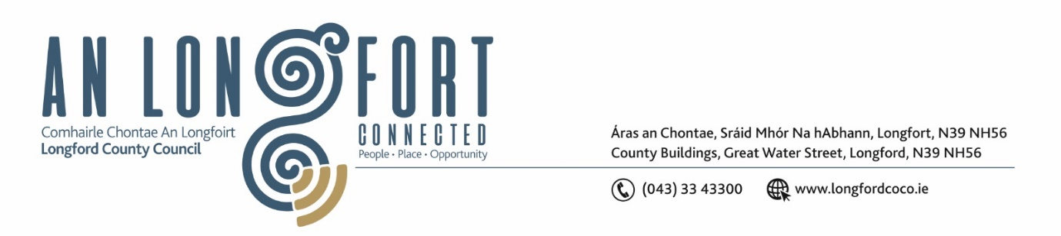
LONGFORD MUNICIPAL DISTRICT

Please note meeting will be held in the Council Chamber, Aras an Chontae and via Microsoft Teams

16 July 2024

To: Each Member of Longford Municipal District.

Dear Member,

You are requested to attend the Meeting of Longford Municipal District to be held in the Council Chamber, Aras an Chontae and via Microsoft Teams on Tuesday, 23 July 2024 at 11 am to transact business, as set out on the agenda hereunder.

Yours sincerely,

_______________
Claire McNabola
Meetings Administrator

AGENDA

Prayer before meeting.

1. Confirmation of Minutes:

- Longford Municipal District Meeting held on 22 May 2024 – enclosed.
- Longford Municipal District Annual Meeting held on 24 June 2024 – enclosed.

2. Matters arising from Minutes.

3. Declaration of Interest by Members.
4. Consideration of Draft Standing Orders for Longford MD

5. Management Report – enclosed

6. Introduction to new Local Healthy Age Friendly Healthy Homes Co Ordinator

7. Consideration of Part 8 – The Mall Outdoor Facilities upgrade, Longford
8. Notice of Motions

Councillor Seamus Butler
- That Longford Municipal District agrees a 5 year footpath rehabilitation programme with the Executive and Engineering staff commencing in Autumn 2024

Councillor Gerry Hagan
- I call on Longford MD to carry out resurfacing works and re instatemet of road markings on the Newtownforbes to Rooskey Road at Ballagh Bridge.
This stretch of road is in a very poor state of Repair and is an accident waiting to happen as road markings are completely disappeared.
- I call on Longford MD to request Bus Eireann to move bus stop from outside the church in Newtownforbes Village to further up the street near what was formerly Bohan's.

